**Exercise No: 3**

**Date:14/10/2020**

**Aim:**

We aim to remove every second number from the array and display it.

**Program:**

def every2number(list):

temp = []

p = 1

s = 0

for i in range(0,len(list)):

s = (p+s) % len(list)

el = list.pop(s)

temp.append(el)

return temp

n = int(input("enter the array size: "))

list = []

for i in range (0,n):

list.append(int(input("enter the values: ")))

p = every2number(list)

print(p)

**Link:**

**http://103.53.53.18/mod/vpl/view.php?id=231**

**Output:**

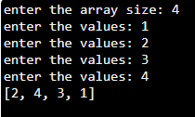

**Result:**

The output has been successfully executed and verified.